|  |
| --- |
| Ciconi’s Games |
| **AIRFIRE** |
| **Space War** |
| Andre Lemos, Fabio Ciconi and Rodrigo Geronimo  Version #3  All work Copyright © 2017 by Ciconi’s Games.  All rights reserved. |
| **Andre Lemos, Fabio Ciconi, Rodrigo Geronimo** |
|  |

|  |
| --- |
| August 18th 2017 |

**Table of Contents**

Contents

Version 4

1. Game Overview 5

2. Game Play Mechanics 5

3. Camera 6

4. Controls 6

5. Interface Sketch 6

6. Menu and Screen Descriptions 9

7. Game World 10

8. Levels 10

9. Game Progression 10

10. Non-player Characters 10

11. Enemies 11

12. Abilities 11

13. Vehicles 12

14. Story Index 12

15. UML 12

16. Future Features 12

# Version

Version 1.0 – Document start

Version 2.0 – Stage 2 created

Version 3.0 – Final details implemented

# Game Overview

Are you prepared to face the best adventure of your life? You need to protect planet Earth from asteroids and other enemies. Embark on the AirFire007 ship and do not let the land be destroyed. When the Earth loses the ozone layer you don’t have another option, you need to save your planet from the aliens. AirFire007 is an amazing spaceship, it is fast, powerful and can destroy everything with the powerful shoot blue ball explosion. You will get into this war, prepare your helmet that AirFire007 is waiting for you.

# Game Play Mechanics

The mechanic is simple: the player needs to eliminate the asteroids and kill the wave of enemy ships. The player needs to define what is the best position to stay to defeat the enemy ships and escape the asteroids. The player can destroy the enemy ships with fire and can escape or destroy the asteroids.

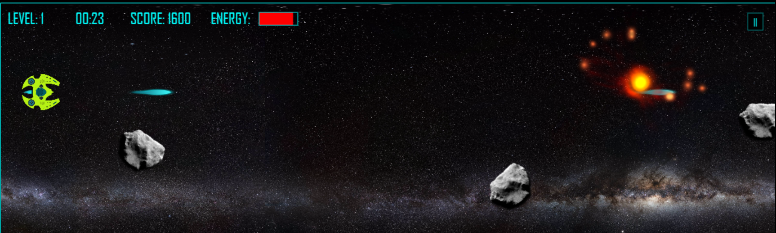

The screenshot shows the ability of the spaceship to fire and destroy the asteroids.

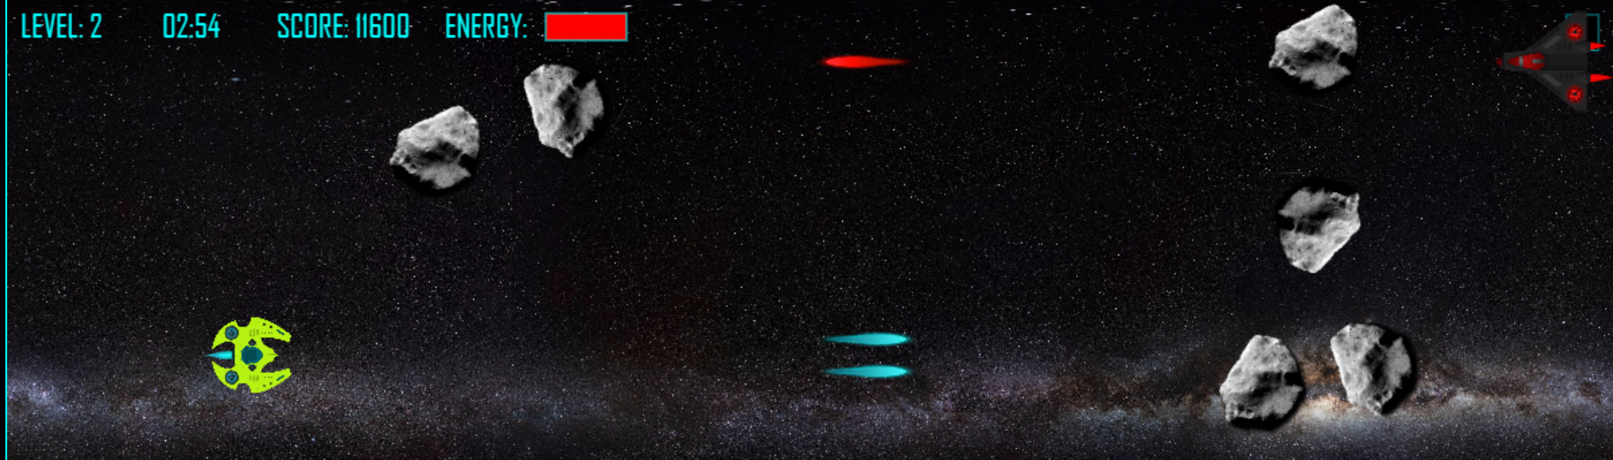

The screenshot shows the ability of the spaceship to double fire and destroy the asteroids and an alien spaceship.

# Camera

The game uses a 2D side-scroller, the camera does not change position.

# Controls

The game uses a simple up, down, left and right keyboard buttons and space bar to fire.

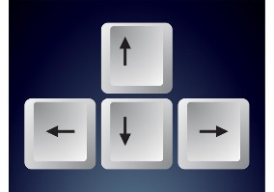

# Interface Sketch

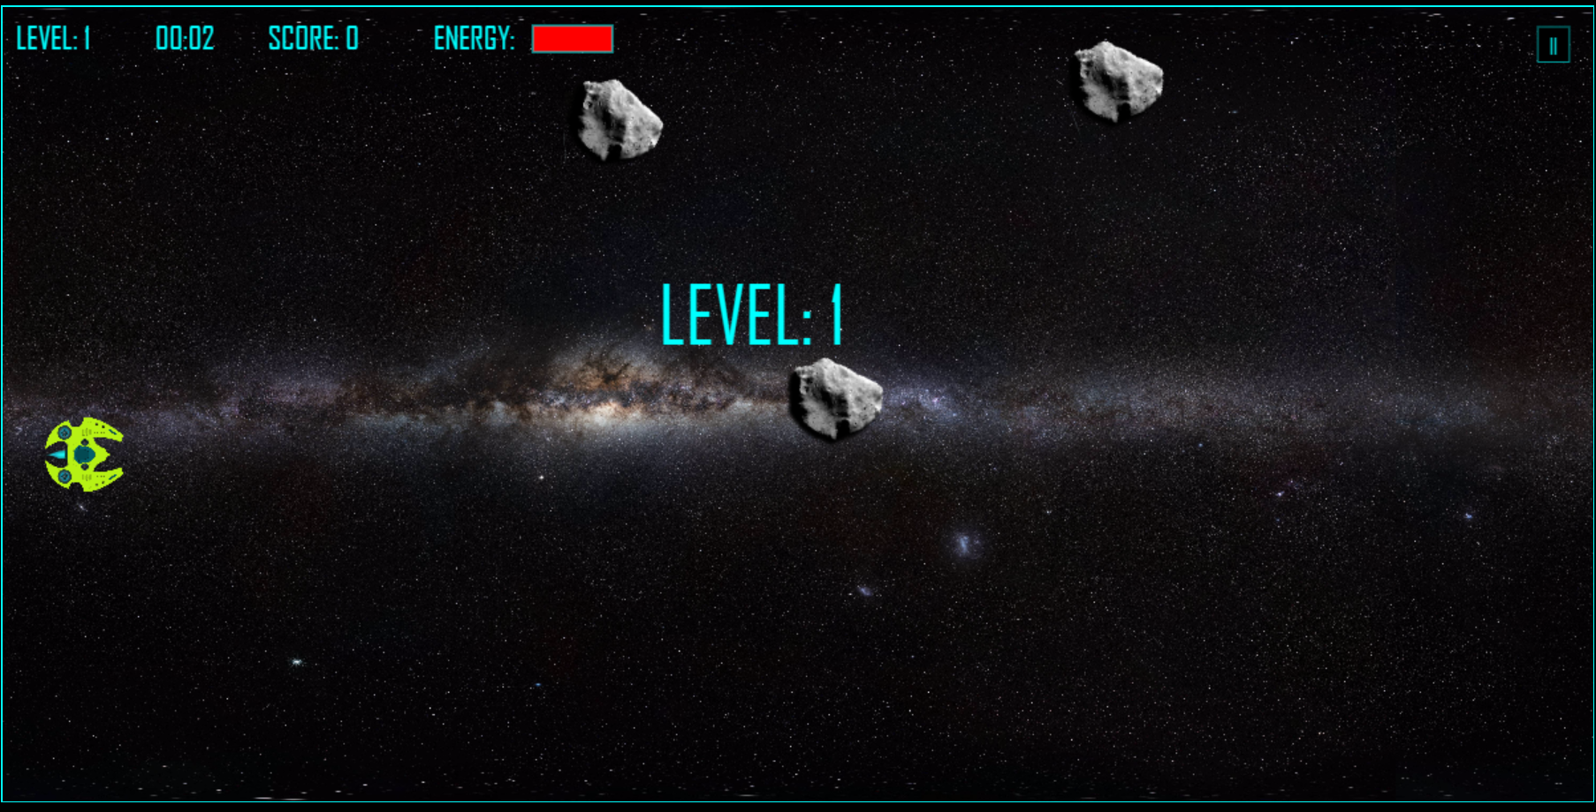

Screenshot of the game in level 1 when the level starts.

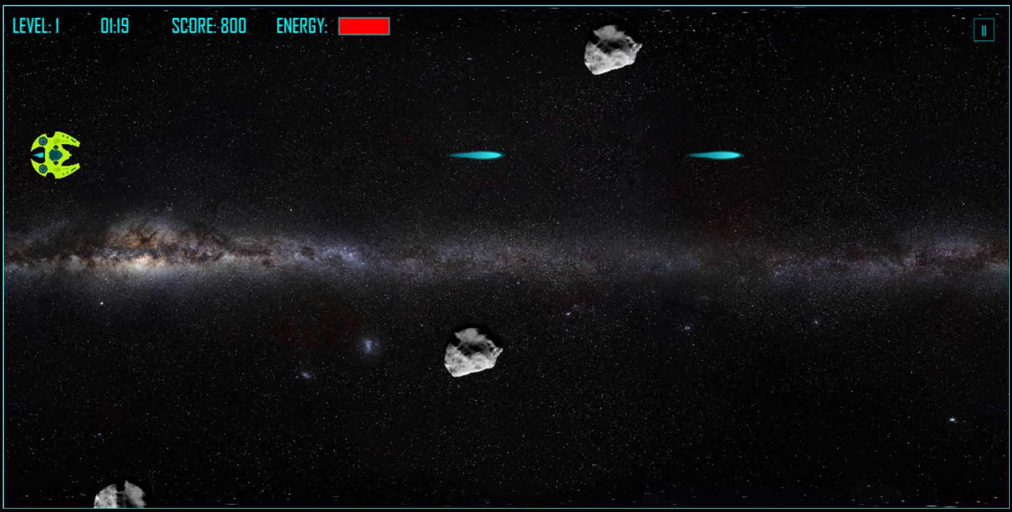

Screenshot of the game in level 1 when the player fires.

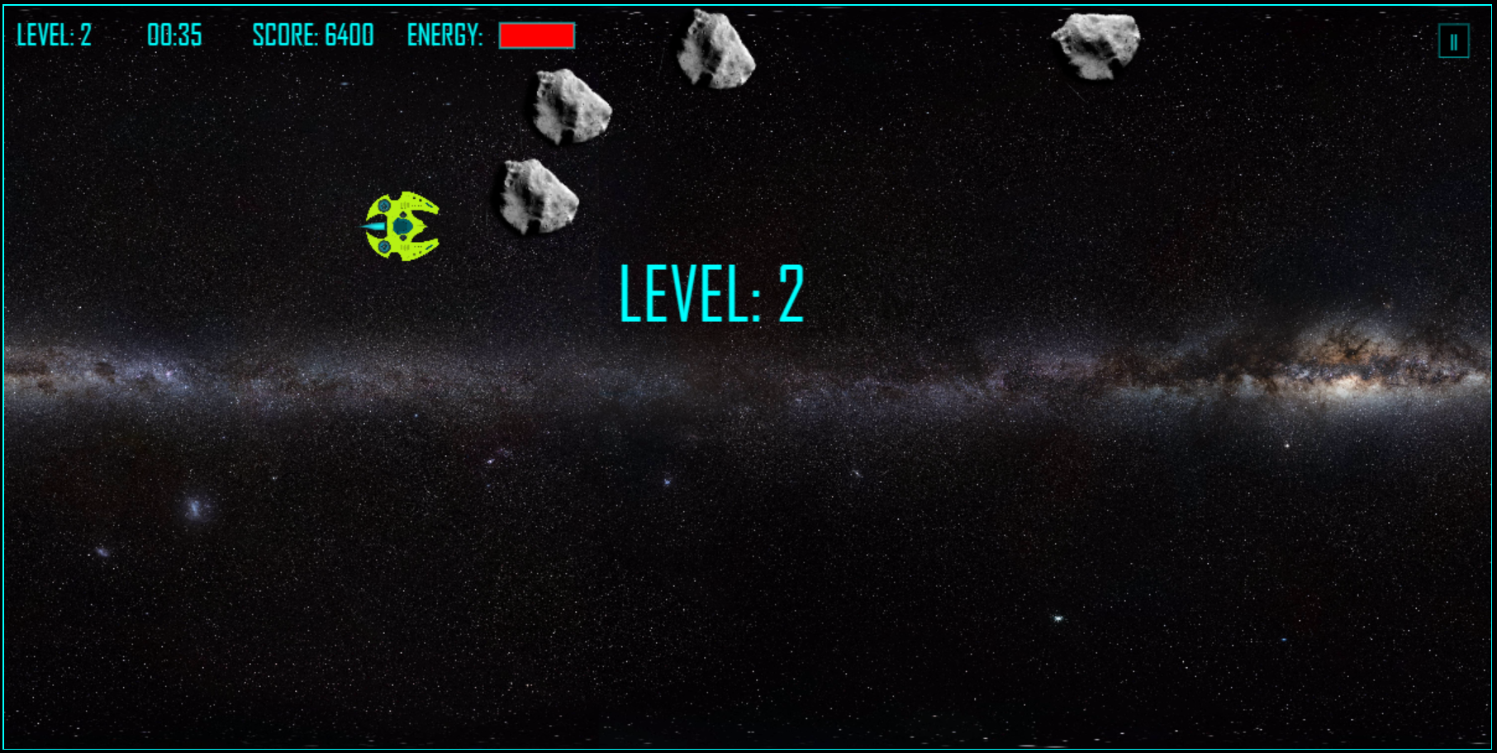

Screenshot of the game in level 2.

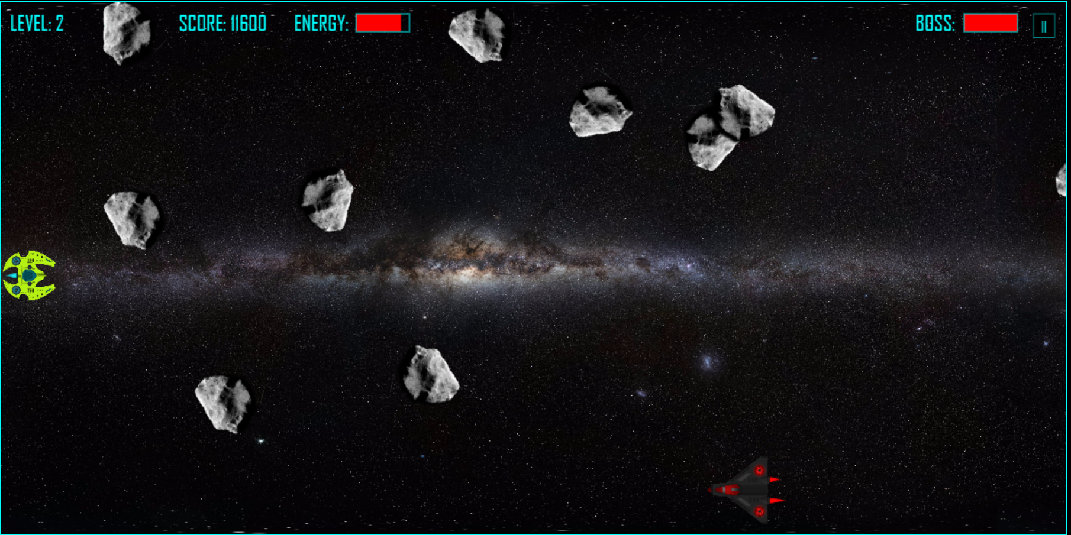

Screenshot of the game in level 2 when the player faces the first boss.

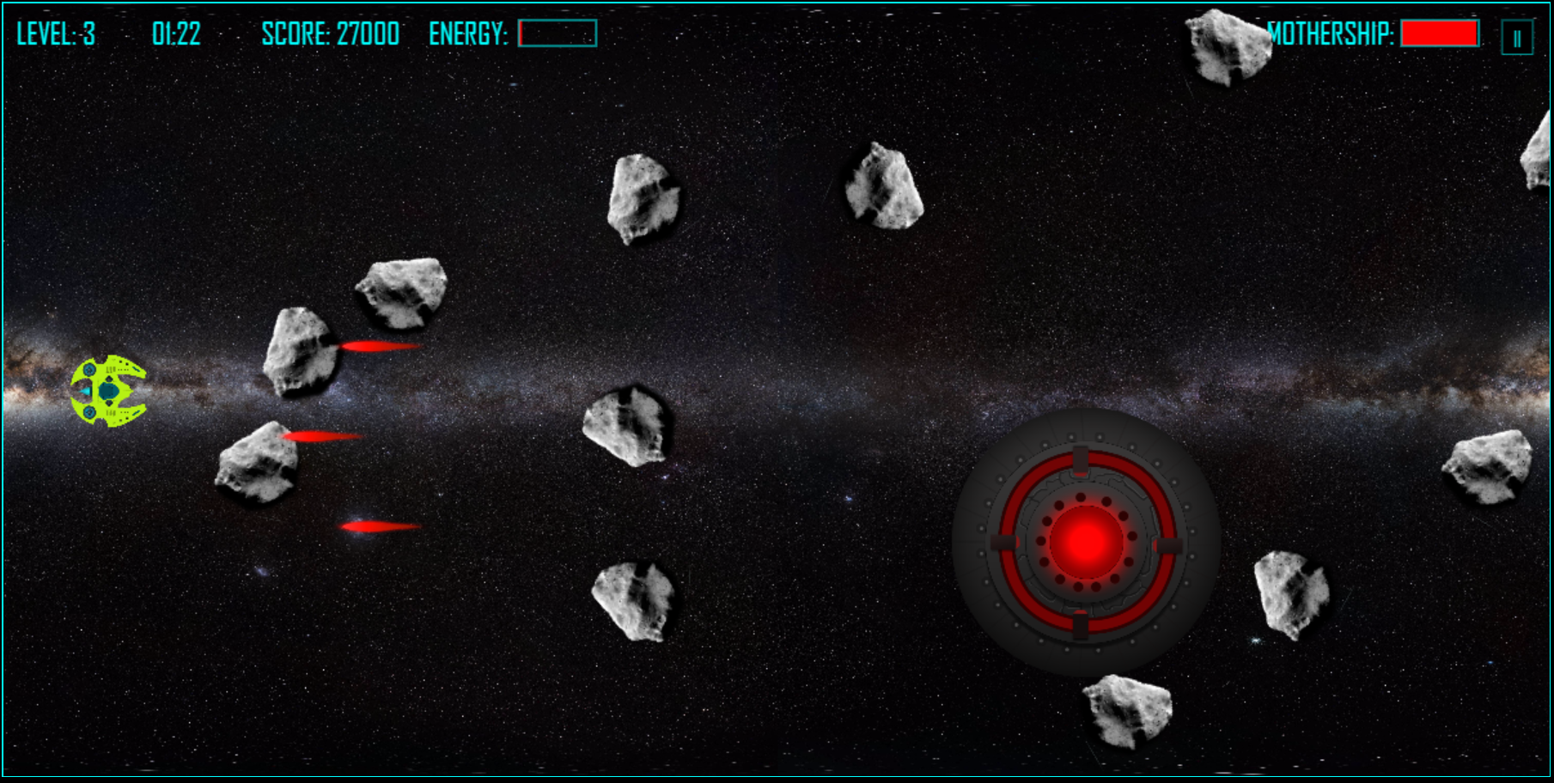

Screenshot of the game in level 3 when the player faces the mothership triple shot.

# Menu and Screen Descriptions

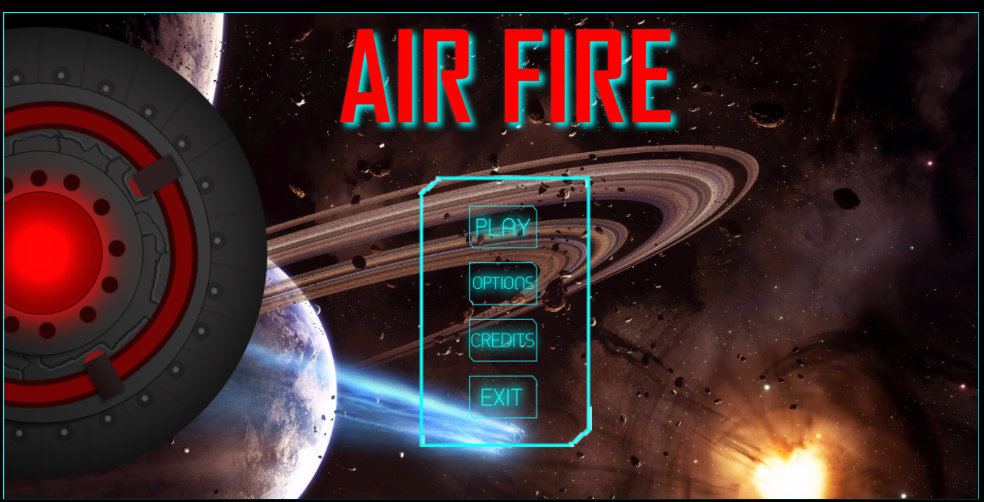

The main menu is divided into 4 options: Play, Options, Credits, and Exit.

* PLAY button is to start the game.
* OPTIONS button is to show the spaceship control.
* CREDITS button is to show the creators’ information.
* EXIT button is to close the game.

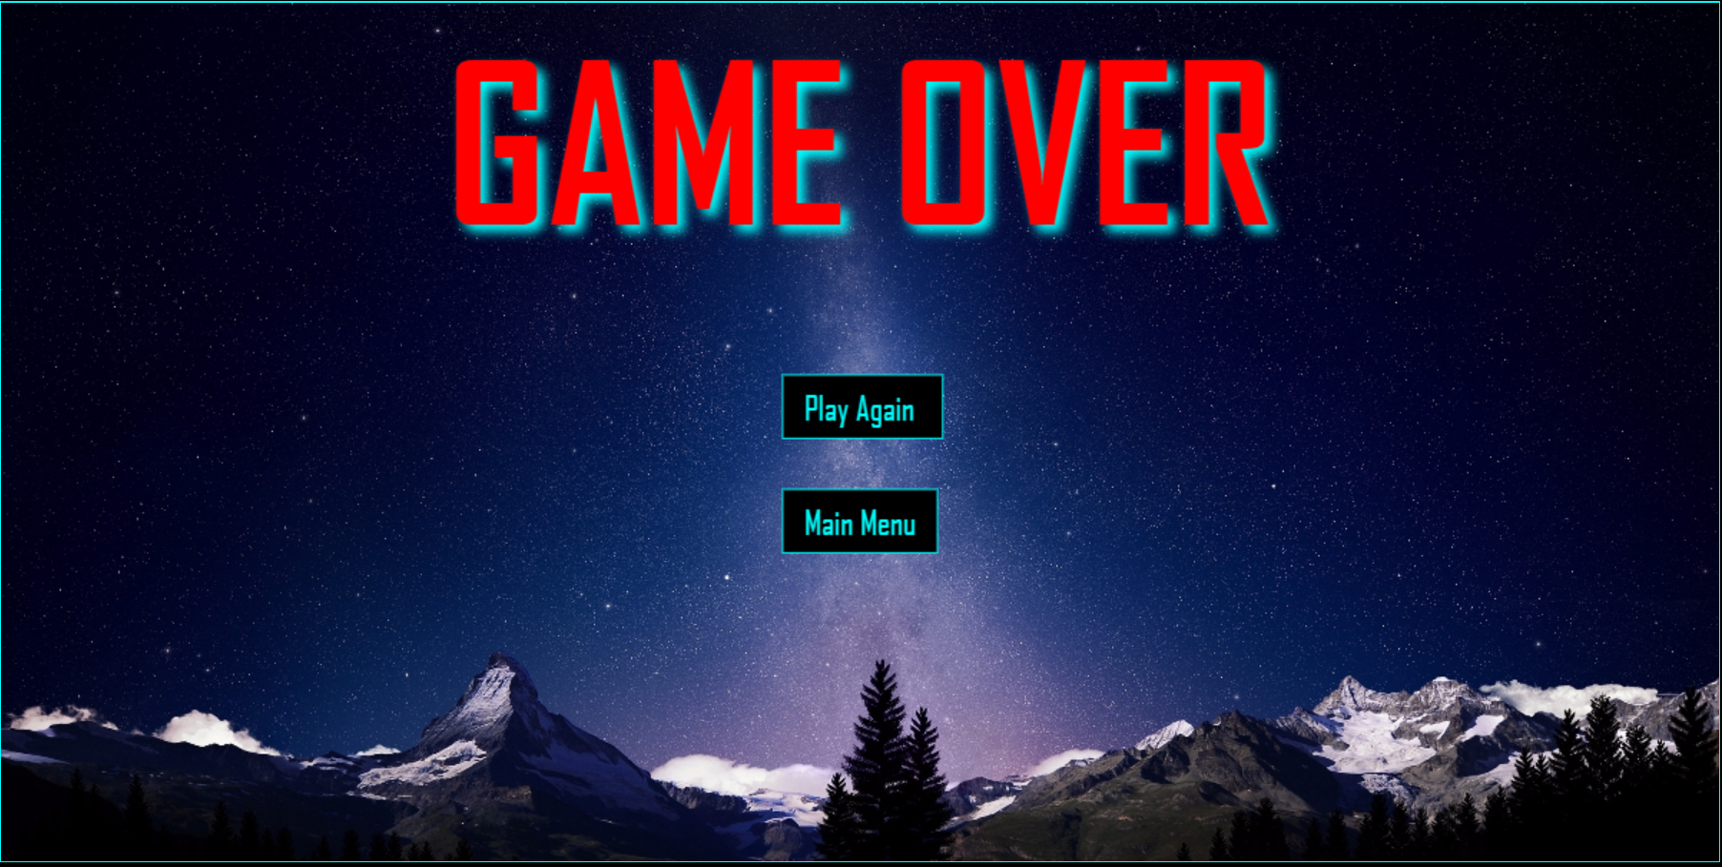

The game over menu appears when the player loses the game. The game over menu is divided into 2 options: Main Menu and Play Again.

* Main Menu button is to go to the Main Menu scene,
* Play Again button is to start the game again.

# Game World

The game happens in 2100 and the humankind remains living on Earth. However, we discovered that life in universe life beyond us. Some aliens are peaceful, but others are extremely dangerous. Second, the Earth lost ozone layer and the humankind faces some problems with asteroids.

# Levels

The game has 3 levels.

Level 1: The player only fights against asteroids. In the beginning, there are only 3 asteroids. When the player reaches 3,000 points, the number of asteroids is increased to 6. When the player reaches 6,000 points, level 1 is completed. The player can diverge for the asteroids or destroy them. However, the mission of the level 1 is to destroy a such number of asteroids.

Level 2: The player faces 10 asteroids and when the Score reaches 10,000, an enemy ship appears: Boss, who shoots to destroy the player. The player can diverge from the asteroids or destroy them, but he/she needs to destroy the Boss to conclude level 2.

Level 3: The player faces 12 asteroids, and needs to score 10,000 points only in this level to confront the enemy mothership. The same way for level 2, the player needs to defeat the boss to conclude the level.

# Game Progression

1. The first level is easy: the player only destroys asteroids. It needs 6000 points to conclude this level.
2. The second level starts to become more difficult. The speed of the asteroids is increased. The player needs to destroy asteroids and an enemy ship, but the enemy will try to destroy the player as well. The game on this part becomes more challenging for the player. We classify this level with normal difficulty. The Boss needs to be defeated to conclude this level.
3. The level 3 is the final and the hardest level. The player will face 12 asteroids and the Mothership. At least, the player has the double shot on the spaceship available. However, the Mothership fires 3 shots at the same time!

# Non-player Characters

The player doesn’t have control in the enemies. The enemies are controlled by the PC. The asteroids are random controlled.

# Enemies

Asteroid

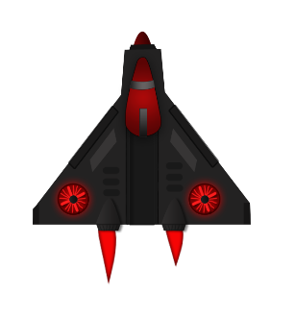Alien spaceship

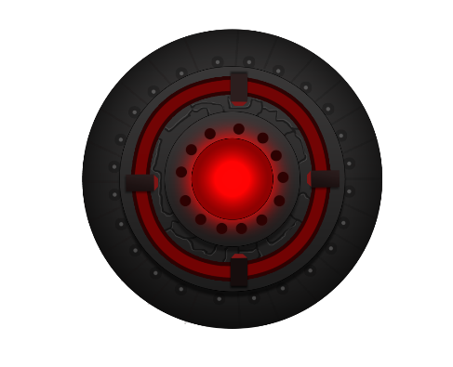Mother alien spaceship

# Abilities

The spaceship has the ability to shoot to destroy the asteroids and enemies.

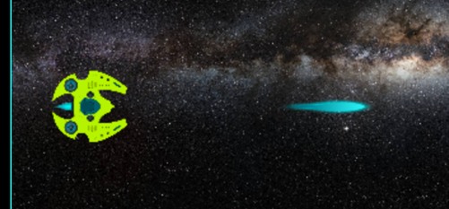 Sprite sheet for the spaceship shoot



# Vehicles

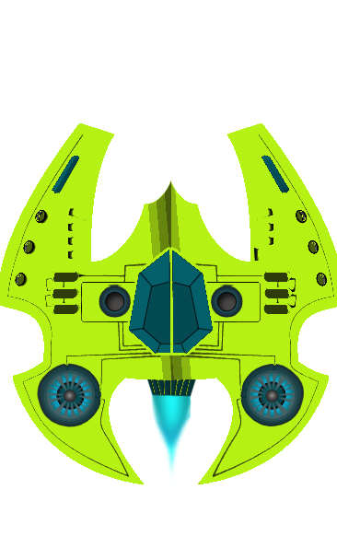Spaceship

# Story Index

The Earth needs new pilots to protect itself. The mission of the new pilots is to destroy the asteroids and enemies’ spaceships.

# UML

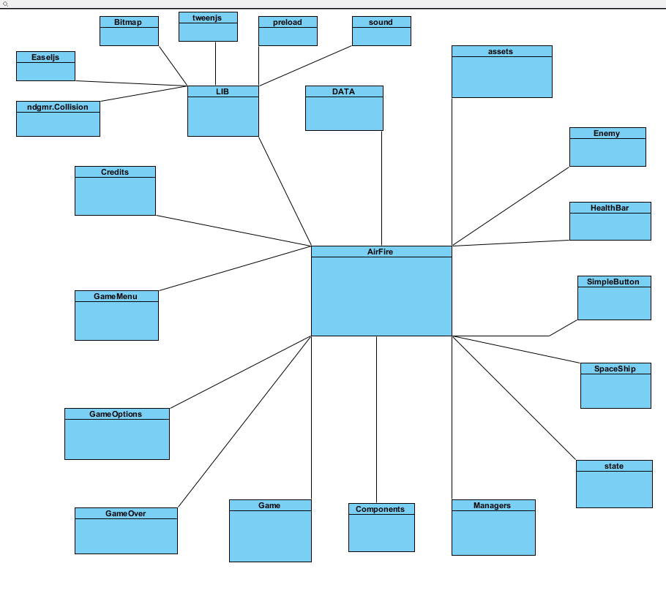

# Future Features

The Game is completed. However, the game has some bugs which can be fixed. Second, the artificial intelligence of the alien could be improved. Therefore, the game future will be implementing the multiplayer platform and more stages.